**Application**

Refer to the Air Quality data described previously, and the analyses we have done with Ozone as the response variable, and the five explanatory variables (including the two engineered features).

Use regression trees to model the relationship between Ozone and all five explanatories

as specified below.:

1. Fit a regression tree using only Temp and Wind, using cp=0.

(a) **Print out the cp table.**

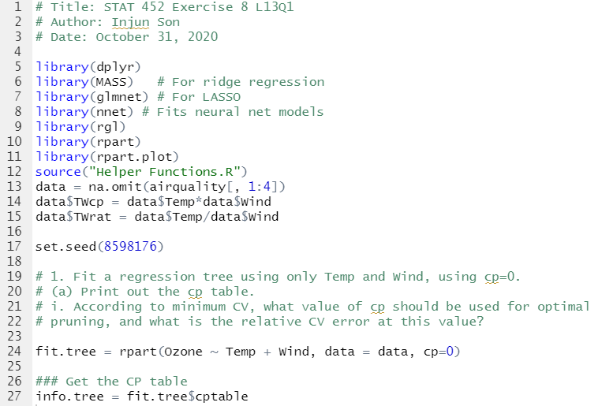

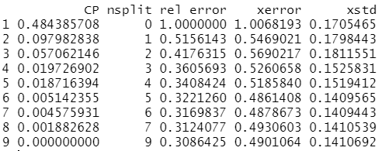

i. According to minimum CV, **what value of cp should be used for optimal**

**pruning, and what is the relative CV error at this value?**

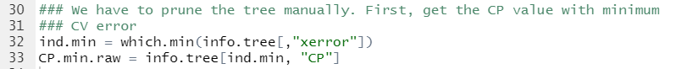



Relative CV error is 0.3221260

(b) **Plot both the min-CV pruned tree and the 1SE pruned tree.**

i. Interpret the first split on the root node: **What variable and split location**

**are used is used, how many observations go each way, and what are**

**the new means in each node?**

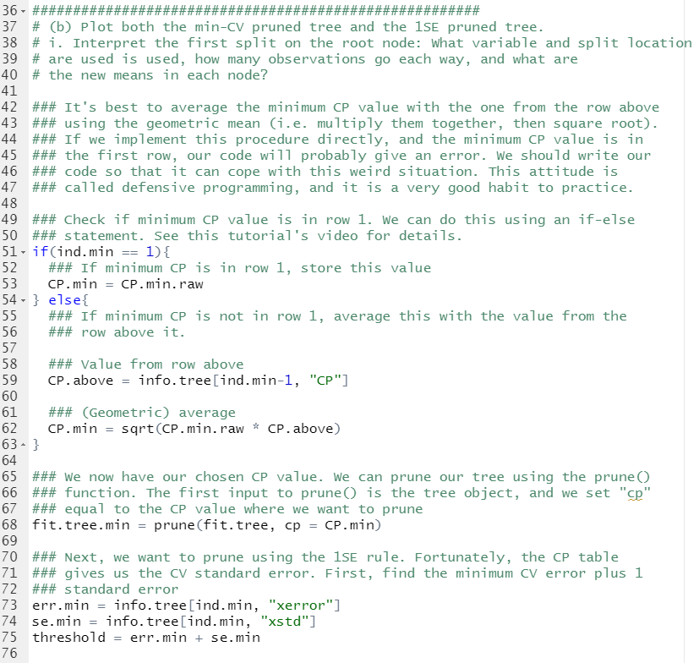

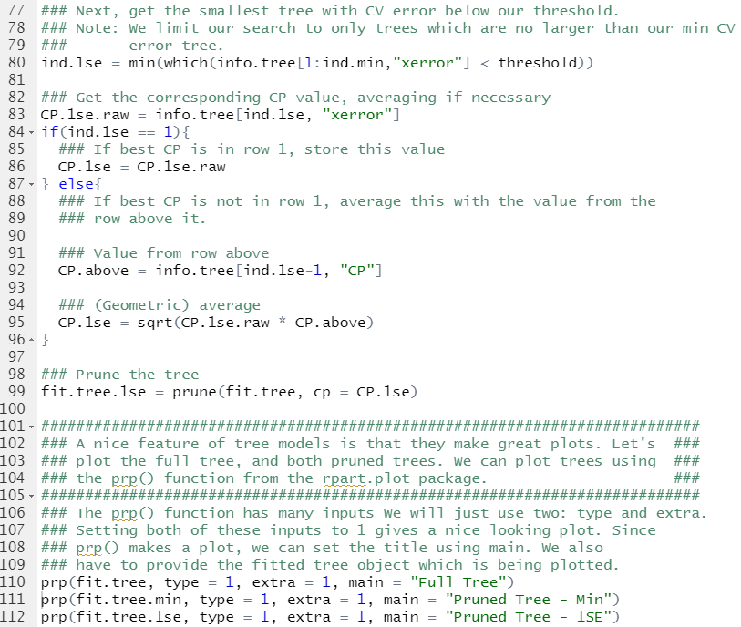

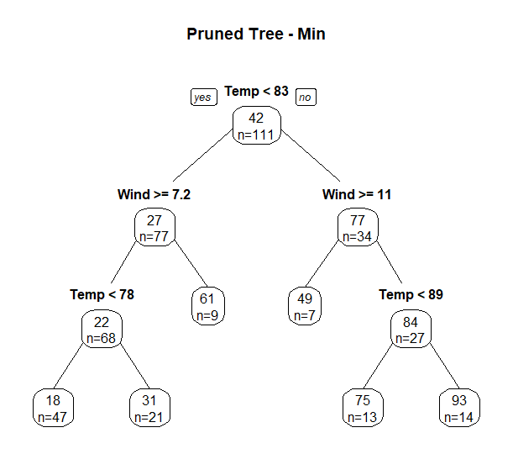

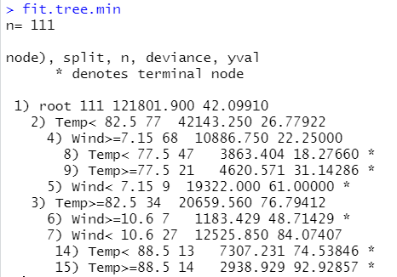

Temp variable was used in the root node and 77 variables that Temp<82.5 goes left and 34 variables that Temp >=82.5 goes right. The new mean is 26.77 for variables that Temp< 82.5 and the new mean is 76.79

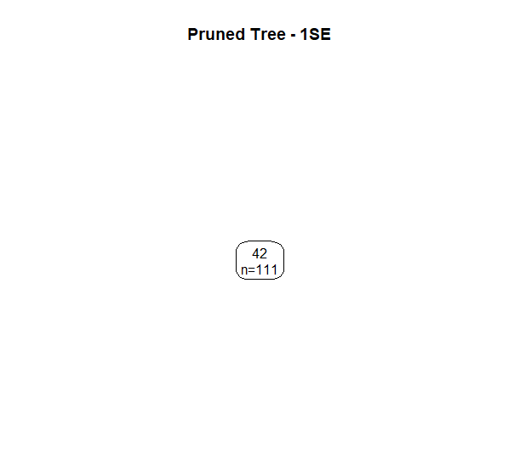

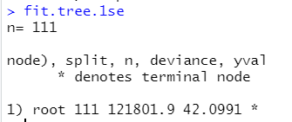

1SE pruned tree didn’t split the data.